### **1. Education**

**Prompt**:  
 *“A futuristic classroom in 2040 where students learn alongside AI companions, using holographic textbooks, voice-controlled interfaces, and immersive VR lessons, with Earth’s solar system rotating in real time on a transparent wall screen.”*

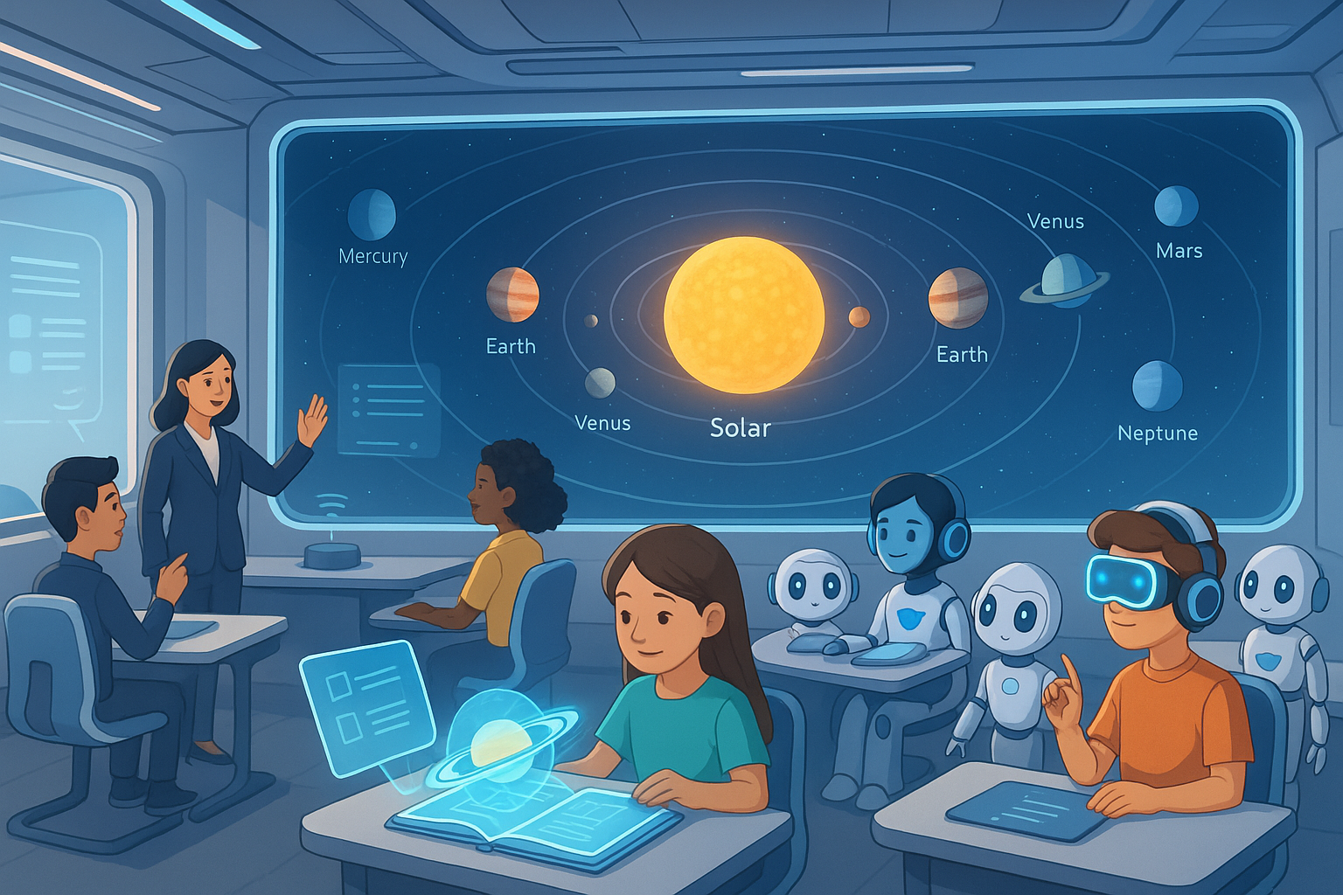

🎯 *Use for*: Educational concept visualization, EdTech presentations, or sci-fi storytelling.

### **2. Entertainment / Film**

**Prompt**:  
 *“A dramatic action scene where a time-traveling archaeologist escapes an ancient collapsing temple filled with floating glyphs and glowing artifacts, while reality glitches between historical timelines—Mayan jungle, Egyptian desert, and a neon-lit cyberpunk city.”*

🎯 *Use for*: Movie concept trailers, storyboarding, or cinematic experiments.

### **3. Environment (Short Awareness Clip)**

**Prompt**:  
 *"A polluted beach cleans itself in reverse motion — trash disappears, sea turtles return, and the ocean shifts from murky brown to crystal blue in a seamless time-lapse animation, lasting 10 seconds."*

🎯 *Great for*: Environmental awareness, social media campaigns, NGO reels.

### **4. Technology (Demo Visual)**

**Prompt**:  
 *"A close-up 10-second clip of a person scanning a QR code at a public transit station, followed by a smooth animation of their phone displaying live updates and a digital map of the train system."*

🎯 *Use for*: Smart city demos, tech product videos, UX design showcases.

### **5. Cultural / Art & History**

**Prompt**:  
 *“A surreal dance performance in a floating museum of lost civilizations, where dancers morph into ancient sculptures mid-movement, shifting through Roman, Aztec, and Japanese Edo-era styles with ambient lighting and ethereal music.”*

🎯 *Use for*: Creative arts projects, cultural fusion pieces, or digital exhibitions.